Experiment No. 2

**Aim:** To develop Software Requirement Specification (SRS) document in IEEE format for the project.

**Theory:**

**SRS Software Requirements Specification**

A document that specifies most of the requirements as required by the customer and as understood by the software engineer.

A well formatted document that includes scope, purpose, product perspective, software and hardware requirements, functional and non-functional requirements for the product.

**Performance:**

1. Identify a suitable case study with the scope for software engineering process.
2. Explain the abstract in one page clearly explaining the project with their functionalities.
3. Each project should have at least 4 functional requirements clearly explaining each functionality by referring to the given SRS template.
4. Prepare a well-formatted document

**Conclusion:**

In this experiment we were able to make an SRS for our case study and clearly understood the process and requirements for an SRS.

Software Requirements Specification

for

Travel Buddy

**Version 1.0**

**Prepared by**

**Group Name: Team Wanderlust**

| **Dhruvi Jodhawat** | **60004190032** | **dhruvi.jodhawat@gmail.com** |
| --- | --- | --- |
| **Harvy Gandhi** | **60004190043** | **harvygandhi2@gmail.com** |
| **Junaid Girkar** | **60004190057** | **junaidgirkar@gmail.com** |
|  |  |  |
|  |  |  |

| **Instructor:** | **Dr. Kiran Bhowmick** |
| --- | --- |
| **Course:** | **Software Engineering** |
| **Lab Section:** | **Software Engineering Lab** |
| **Teaching Assistant:** | **Dr. Kiran Bhowmick** |
| **Date:** | **30th April 2022** |

**Contents**

**Revisions iii**

**1** **Introduction 1**

1.1 Document Purpose 1

1.2 Product Scope 1

1.3 Intended Audience and Document Overview 1

1.4 Definitions, Acronyms and Abbreviations 1

1.5 Document Conventions 1

1.6 References and Acknowledgments 2

**2** **Overall Description 3**

2.1 Product Perspective 3

2.2 Product Functionality 3

2.3 Users and Characteristics 3

2.4 Operating Environment 3

2.5 Design and Implementation Constraints 4

2.6 User Documentation 4

2.7 Assumptions and Dependencies 4

**3** **Specific Requirements 5**

3.1 External Interface Requirements 5

3.2 Functional Requirements 6

3.3 Behaviour Requirements 6

**4** **Other Non-functional Requirements 7**

4.1 Performance Requirements 7

4.2 Safety and Security Requirements 7

4.3 Software Quality Attributes 7

**5** **Other Requirements 8**

**Appendix A – Data Dictionary 9**

**Appendix B - Group Log 10**

**Revisions**

| **Version** | **Primary Author(s)** | **Description of Version** | **Date Completed** |
| --- | --- | --- | --- |
| 1.0 | Dhruvi Jodhawat  Harvy Gandhi  Junaid Girkar | First Draft. | 30/04/22 |
|
|

# 

# 

# Introduction

## Document Purpose

This is a SRS for the project Travel Buddy - Version 1.0. The purpose of this Software Requirement Specifications document is to clearly define the technical aspect of the product we intend to build. It covers how the first version of the application will interact with the users, hardware, software and other interconnecting applications. It specifies the requirements, technical details and the limitations of the project which shall help us ensure we utilize all the factors correctly, satisfy all product requirements and provide the best possible product to our users.

## Product Scope

The project scope is not limited to a specific city or a country but it has an extensive scope at a global level. The project will be used by people who are going on vacations and are searching for destinations. If people already have a location in mind, they can search for detailed information about that location and nearby places to visit. For those users who don’t have a decided location, the project will recommend places based on travel history, time and weather based analysis. Local authorities can also use this project to update information about places and to get advance ideas about incoming tourist traffic. The project will not be a booking platform and will be just for sharing information.

## Intended Audience and Document Overview

The document is organised in a climactic sequence. The document opens with a brief abstract that introduces the theme and sets the tone for the subsequent parts. Following that, the document describes its characteristics and introduces the issue statement. It then goes on to provide an overview of the project's users, environment, and limits. The document then goes on to describe the different interfaces and project needs. The document also includes references to pertinent research publications and sources. The document is intended for all users as well as the project's technical developers.

The intended audience for this mini project is firstly the local authorities. By accessing the clusters formed after extracting the tourist information, the local authorities can get an idea of what the tourists are enjoying along with which areas are receiving less footfall than expected. Investments can be made along similar lines. The other target audiences would be tourists who would like to know the major attractions in an area that too from actual social media posts rather than the tourism related websites. The other target audiences are researchers who will search for appropriate data and collect various ways to perform further analysis.

## Definitions, Acronyms and Abbreviations

Some of the terms that can be frequently encountered in the SRS are listed below

* **Behaviour Analysis** - Finding recurring patterns in data for future recommendations.
* **Data Extraction** - Scraping of data from social media.
* **GUI** - Graphical User Interface.
* **RAM** - Random Access Memory
* **API** - Application Programming Interface
* **GPS** - Global Positioning System

## Document Conventions

The following conventions were followed while creating the document:

* We have used the IEEE standards for document formatting.
* The font used is Arial, font size for title is 14 and font size for text is 12.
* Italics have been used for comments.
* 1” margin has been maintained throughout the document.
* The text is single spaced.

## References and Acknowledgments

<https://www.frontiersin.org/articles/10.3389/fpsyg.2020.00599/full>

[https://www.researchgate.net/publication/345868027_Tourist_Behaviour_Analysis_Base](https://www.researchgate.net/publication/345868027_Tourist_Behaviour_Analysis_Based_on_Digital_Pattern_of_Life-An_Approach_and_Case_Study)

[d_on_Digital_Pattern_of_Life-An_Approach_and_Case_Study](https://www.researchgate.net/publication/345868027_Tourist_Behaviour_Analysis_Based_on_Digital_Pattern_of_Life-An_Approach_and_Case_Study)

<https://ieeexplore.ieee.org/document/9263945>

<https://studentprojectguide.com/wp-content/uploads/2017/11/Travel-And-Tourism-Management-System-SRS.pdf>

<https://www.sciencedirect.com/science/article/abs/pii/S0378720616303573>

<https://www.google.com/maps/>

<https://mausam.imd.gov.in/imd_latest/contents/all_india_forcast_bulletin.php><https://phpgurukul.com/tourism-management-system-free-download/>

# Overall Description

## Product Perspective

The project makes use of the extensive geotagged images available on social media for data collection and develops a comprehensive review system with the help of image and text processing which can be passed on to the relevant people. It also structures the tourist demographic data for all locations in the vicinity and predicts tourism demands for various locations with the help of time variant data.

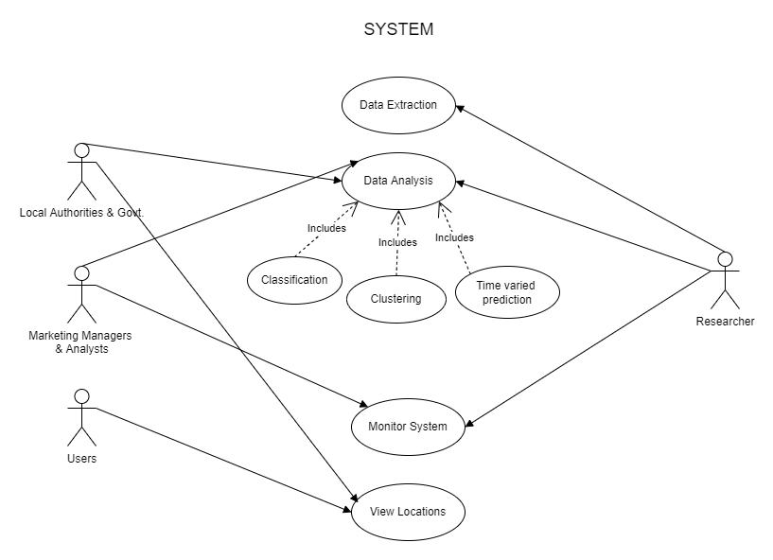

## Product Functionality

* Social media images that are geotagged will be collected and analyzed to find recurring patterns.
* All the details about a location and any nearby locations will be consolidated and users can use the project to get specific directions to any of these locations or any nearby popular spots.
* Recommendations will also be done according to the user's travel history, time variant analysis and weather forecasting.
* Local authorities can update information about the tourism spots and based on the analysis of the tourism traffic, they can take appropriate measures.

**DFD:**

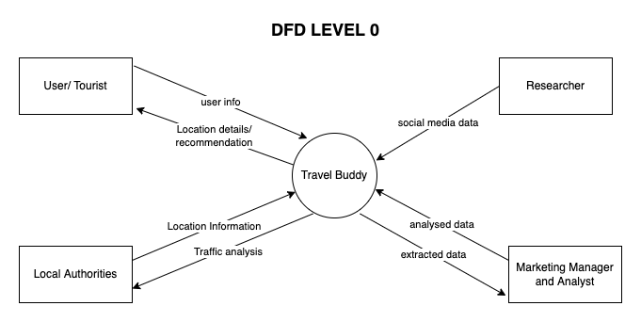

## Users and Characteristics

* **Users**: They travel and use the analysed data for making decisions.
* **Local Authorities and government:** There is constant communications between data analysts and the local authorities to be updated with the current data.

## Operating Environment

* **Recommended browsers:** Chrome, Firefox, Safari, Edge and Brave.
* **Recommended Operating systems:** Windows, MacOS, IpadOS, iOS, wear OS, watchOS, Android and Linux.

## Design and Implementation Constraints

* The system is limited by its operating server in terms of the maximum number of users and queries it can support at a given time.
* Isn't compatible with devices without GPS.
* Network Connectivity issues
* Requires Large RAM.

## User Documentation

* The user manual will contain all the guidelines for handling software as well as FAQ section for reference.
* Contact us & support center.
* Cultural differences.

## Assumptions and Dependencies

* We assume that the location mentioned is correct and has been actually visited by the tourist.
* We assume location views the same day for all years.
* The photo uploaded on social media is actually of a tourist place
* The database must store that the year mentioned by the tourist is correct without any discrepancies.
* We assume that the place mentioned in the image is are the in a database which is secured and should not be tampered by any unauthorised person.
* We assume that the geotags we get via third party API for are relevant and accurate.

# Specific Requirements

## External Interface Requirements

### User Interfaces

**Landing Page**: This will be the first page the users will see upon opening the webapp. It will give an introduction about our organization and will show the current trends in tourism locations.

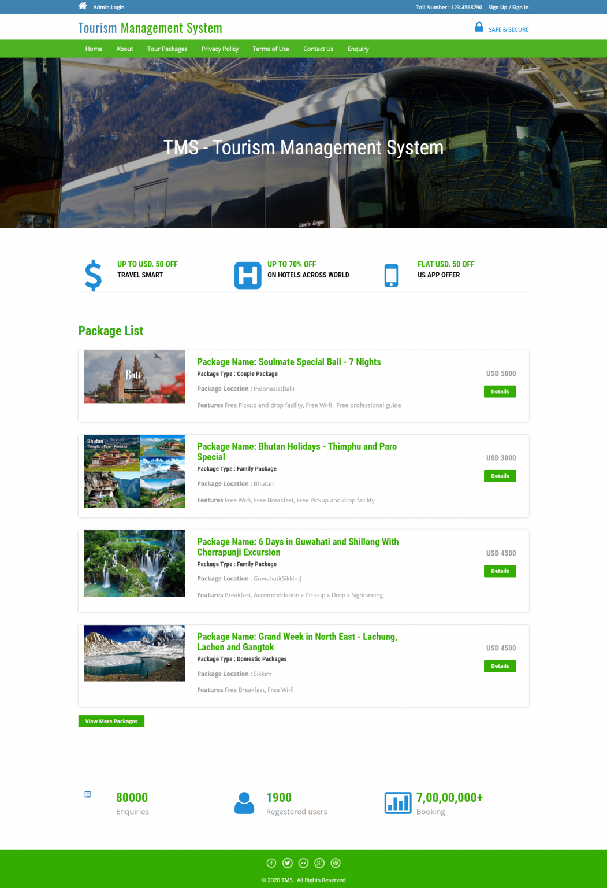

Login Page

Signup Page

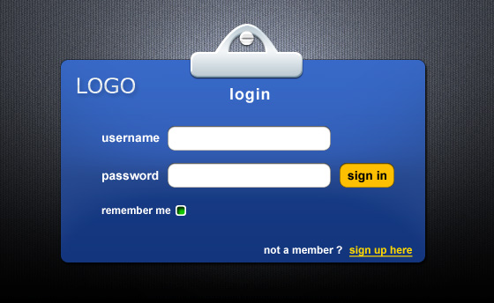

**Dashboard**: This page will open once the user has logged in. This will give an overview about the user profile and fill show details about his past travels. There will be a navbar on the side that will have links for Search Page, Past Travels and Travel recommendations

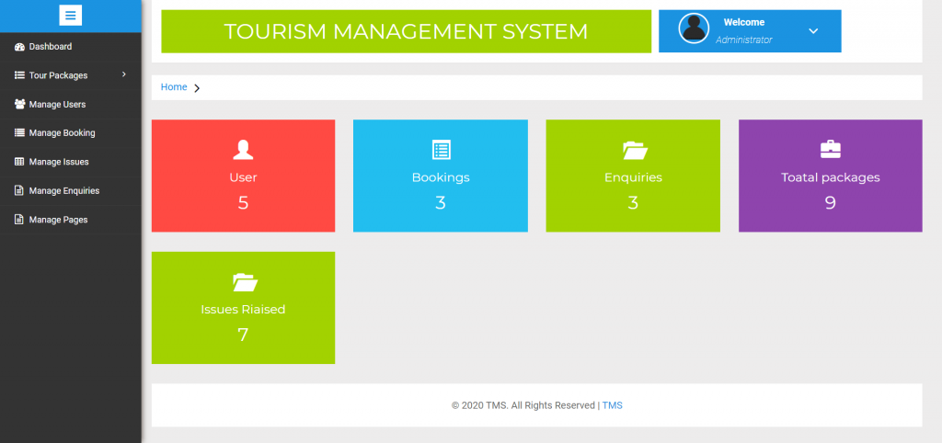

**Home Page**: This is the first page on the dashboard.

**Search Page**: Here the user can search for locations as per their preferences.

**Past Travels**: This will show a list of the user’s travel history.

**Travel Analytics and Recommendations**: This will have recommendations for the user based on the trained model and user’s travel history.

**Local Authority**:

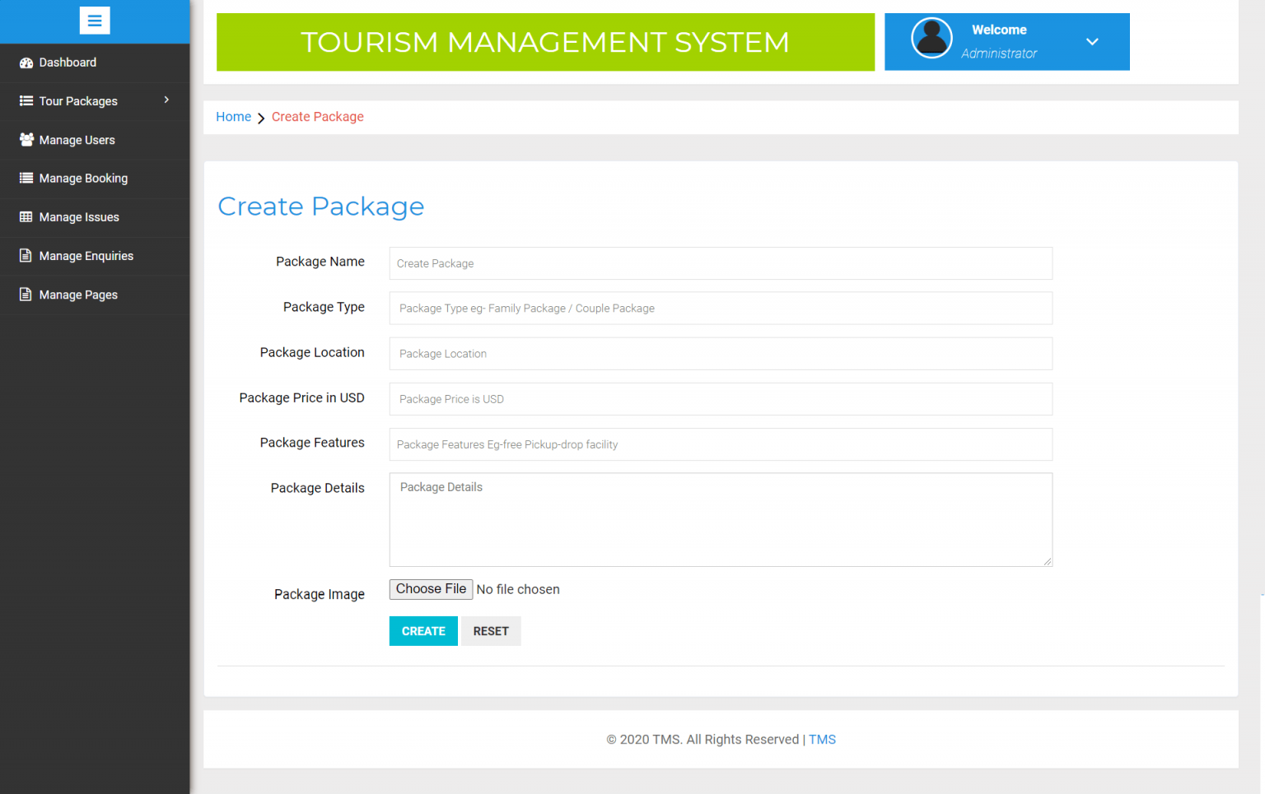

**Login**

**Signup**

**Data Updation Page**: This page is used by the local authorities to upload details about locations and to make any corrections in the uploaded data to remove any wrong data that might have been uploaded.

### Hardware Interfaces

**Server**:

RAM: 8 GB

Storage: 2TB SSD:

Processor: Intel Pentium 4 processor or later that’s SSE2 capable

GPU: Nvidia GTX 1050

**User Device**:   
 RAM: 500 MB

Storage: 4 GB Storage

GPS Sensor

### Software Interfaces

**Browsers:** Chrome, Firefox, Safari, Edge and Brave.

**Operating systems:** Windows, MacOS, IpadOS, iOS, wear OS, watchOS, Android and Linux.

**Tools**: Google Colab, Jupyter Notebook

### Communications Interfaces

* Minimum 40 Kbps Internet Speed to ensure lossless connectivity.
* HTTP protocols for servicing the requests and for transmission of data in JSON format.
* AES protocol will be used to encrypt the sensitive data being transmitted.

## Functional Requirements

* **Login / Signup** : This functionality will be used by users to register as well as to login in the platform. All the sensitive credentials will be transmitted and stored in a secure manner.
* **Data Collection** : Geotagged images from social media channels will be collected and stored along with popular nearby tourist spots.
* **Bulletin Updation :** Local Authorities will be able to share live updates and details about spots.
* **Recommendation :** Based on travel history, weather forecasting and time varied data, locations will be recommended to the users.

## Behaviour Requirements

### Use Case View

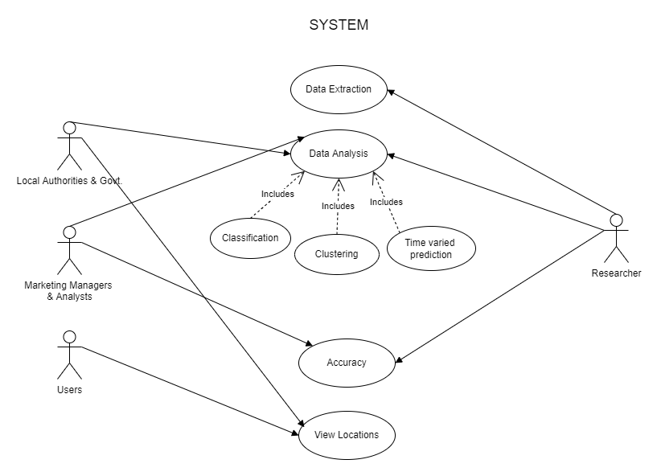

Actors and their user-scenarios:

* **Users** will have access to the deployed software and can give their choice of value as input to get the desired output.
* **Marketing Managers and Analysts** will check out the accuracy of the analyzed data, will form training and testing sets for models and then use the results for visualizing and drawing conclusions. They will need to be informed about any changes in the data that have occurred.
* **Local Authorities** will be the source for data extraction and accuracy checking.
* **Researchers** will perform multiple tasks.
  + They will research and extract data along with relevant information from various sources like the internet, past surveys and the data given by the local authorities and the government.
  + They will then carry out a detailed analysis on the gathered data using classification tools, clustering algorithms, etc.
  + They will then, along with marketing managers and alaysists, check out the accuracy of the analyzed data, form training and testing sets for models and then use the results for visualizing and drawing conclusions.
  + They will need to be aware about any changes that have occurred in the system and might need to inform the concerned people.
  + They will also deploy and manage the deployed software.

# Other Non-functional Requirements

## Performance Requirements

* The analysis should be crystal clear.
* It should provide the desired locations and must be available when required.
* It should be able to extract data from social media platforms at frequent intervals.
* It should store the extracted data in the database so it could be retrieved in the future.
* It should recommend desirable and available locations.
* It should have support for an ample amount of concurrent users.
* Any bugs/queries should be resolved in 3 days.

## Safety and Security Requirements

* The analysis should be of tourist places. This is to ensure that the analysis is not used for inappropriate purposes.
* The extracted images should avoid having personal details of the people in them.
* The database should be secured against attacks of SQL injections and should be accessible only to the authorised person.
* User permission shall be taken to access local storage.
* Users' confidential data shall be saved in an encrypted manner.

## Software Quality Attributes

* **RELIABLE** : Should have sufficient accuracy that the users can rely on it. It should meet client satisfaction standards and be able to gain and maintain their trust.
* **AVAILABILITY** : Whenever the need is there for the analysis it should be available. It should not provide misleading information when it is required the most and function seamlessly.
* **SECURE** : It should have security to ensure it is not tampered with and is not used for illegal purposes.
* **MAINTAINABILITY** : The analysis should be easily maintainable, the users should be able to add delete locations and should be able to update the report with ease at a later time.

# Other Requirements

* Maintenance of the application.
* Updating new functionalities.
* Security of database.
* Frequent updation of data by researchers.

**Appendix A – Data Dictionary**

| **Field Name** | **Data Type** | **Field Size for display** | **Description** | **Example** |
| --- | --- | --- | --- | --- |
| User_name | Text | 15 | Name of each customer | Lord Voldemort |
| Age | Integer | 3 | Age of the customer | 75 |
| Country_of_origin | Text | 20 | Country to which the customer belongs | India |
| Locations_visited | Text | 50 | Locations visited | Hogwarts |
| List_of_tourists | List | 500 | List of tourists | { Harry Potter, Hermoine Granger,  Ron Weasley} |
| Peak_time | Text | 50 | Peak time of attraction | May |

**Appendix B - Group Log**

| **DATE** | **ACTORS** | **WORK DONE** |
| --- | --- | --- |
| 23/04/2022 | Dhruvi, Harvy, Junaid | Analysed Requirements |
| 30/04/2022 | Dhruvi, Harvy, Junaid | Prepared SRS |